

ISLAMIA UNIVERSITY OF BAHAWALPUR

Project Title: Desktop-Based Attendance System using Face Recognition
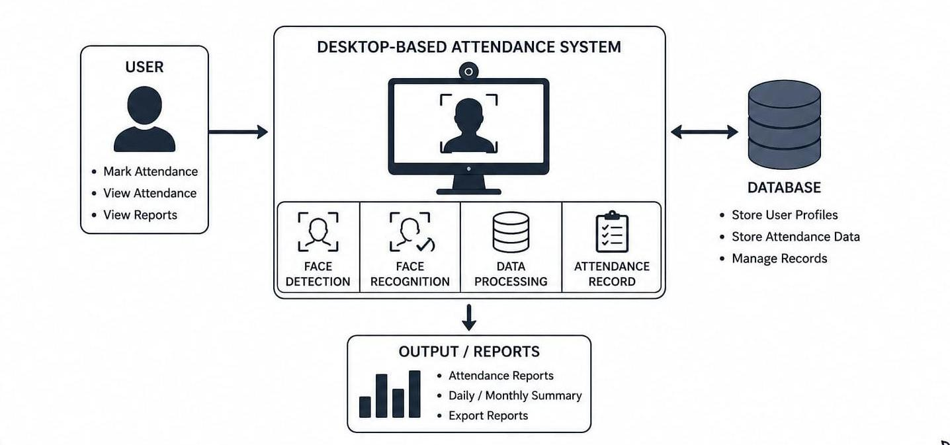
Submitted By:
Nida
Submitted To:
Dr. Rana Nazeer Ahmed
Roll No:
S25BINFT7M04037
Semester:
ADP 7th 1M

Introduction

1.1 Purpose

This document provides a detailed description of the requirements for the Desktop-Based Attendance System using Face Recognition. It is intended for developers, project supervisors, and evaluators to understand the system functionality and constraints.

1.2 Scope
The proposed system is a desktop-based application that automates attendance marking using face recognition technology. It captures student images via a webcam, processes them, and stores attendance records in a local database. The system works offline and is designed for educational institutions.

1.3 Definitions

Face Recognition: A technology used to identify a person using their facial features.
Database: A system used to store and manage data (SQLite).
GUI (Graphical User Interface): A user-friendly interface through which users interact with the system.

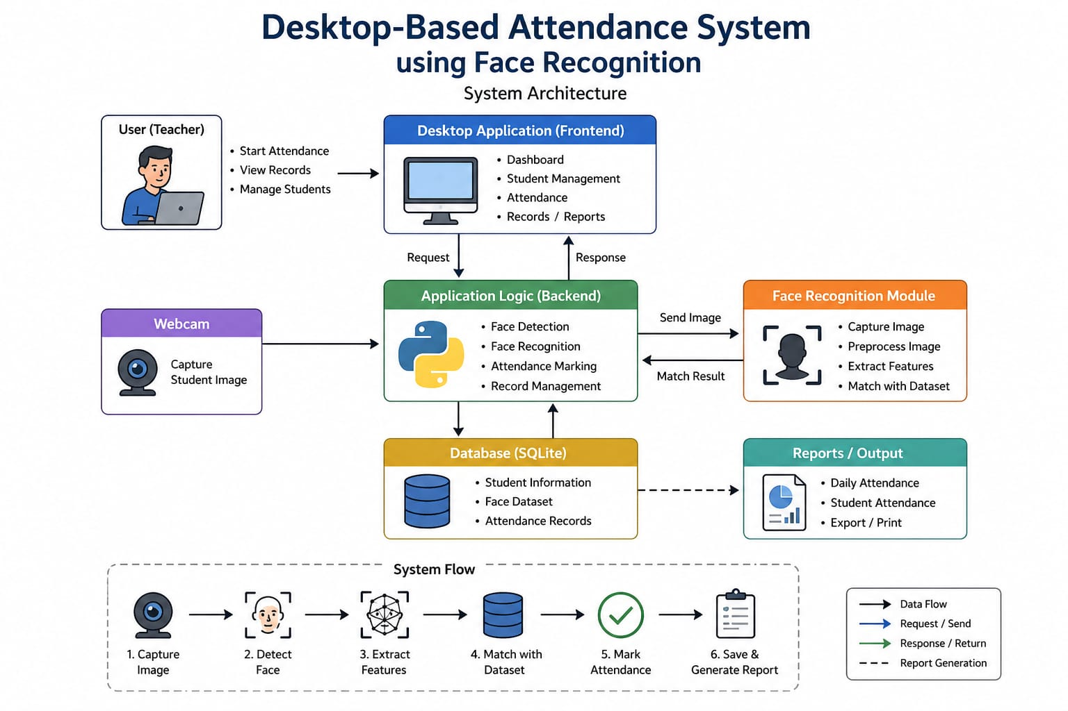

2. Overall Description

2.1 Product Perspective

This system is a standalone desktop application that does not require internet connectivity. It integrates with a webcam for image capture and a local database for storage.

2.2 Product Functions
- Capture student images
- Recognize faces using stored dataset
- Mark attendance automatically
- Store attendance with date & time
- Allow admin to manage student records

2.3 User Classes

Admin:

Manages students and system settings (basic technical knowledge required)

Teacher/User:

Marks attendance and views records (basic computer skills)

2.4 Operating Environment
- Windows OS
- Python Environment
- Webcam Device
- OpenCV Library
- Face Recognition Library
- SQLite Database
- Offline Environment

2.5 Constraints
- Requires a working webcam
- Accuracy depends on lighting conditions
- Works offline only

3. System Features
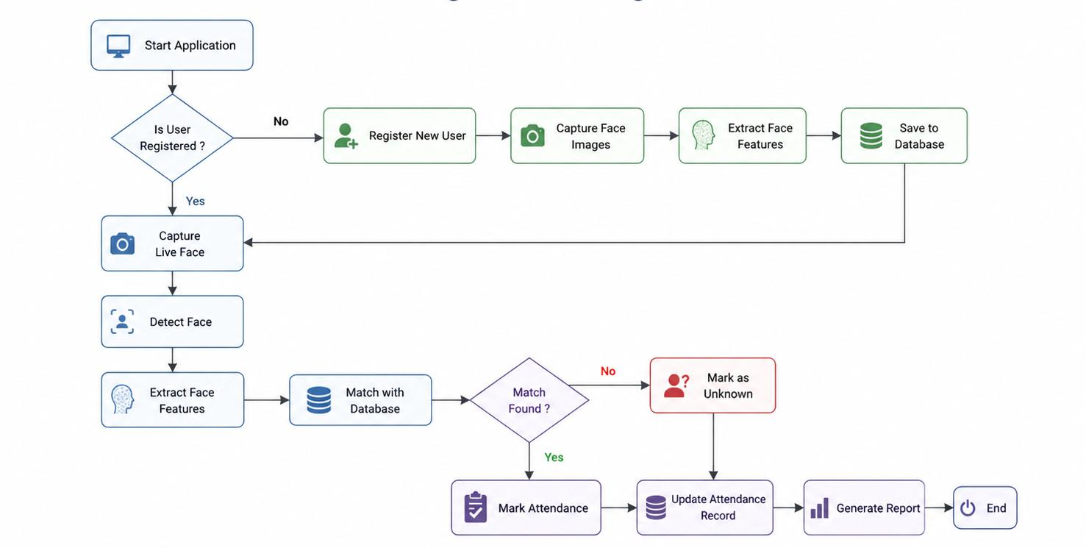

5. Functional Requirements
ID |  | Requirement
FR1: System shall capture student face using webcam

FR2: System shall detect and recognize faces

FR3: System shall mark attendance automatically

FR4: System shall store attendance with date and time

FR5: System shall allow admin to add/delete students

FR6: System shall display attendance records

6. Non-Functional Requirements

Performance
Fast processing (with in seconds).

Security
Data stored securely in local database.

Usability
Simple and user friendly interface.

Reliability
System should work with minimal errors.
Maintainability
Easy to update and modify.

7. System Requirements

Hardware Requirements
. Computer/Laptop
. Webcam
Software Requirements
. Python
. OpenCV
. Face Recognition Library
. SQLite
8. External Interface Requirements

User Interface

. Buttons: Start Attendance, Add Student, View Records

. Simple and clean layout

Hardware Interface

. Webcam for capturing images

9. System Models (Diagrams)

Use case diagram

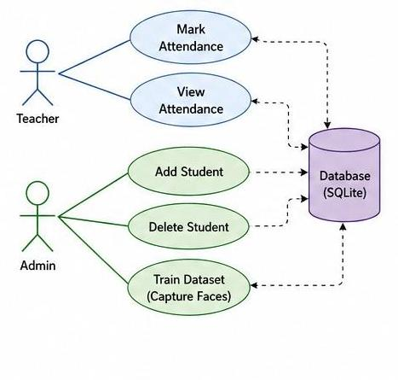
Data Flow Diagram (Level 0)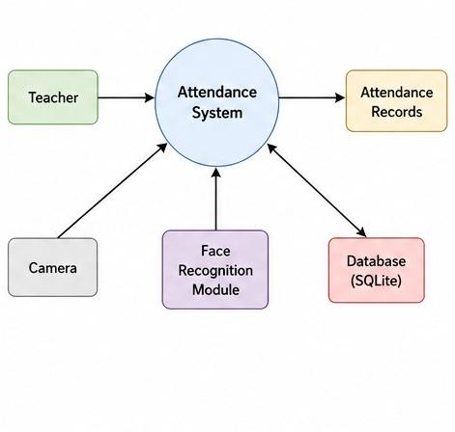

Data Flow Diagram (Level 1)

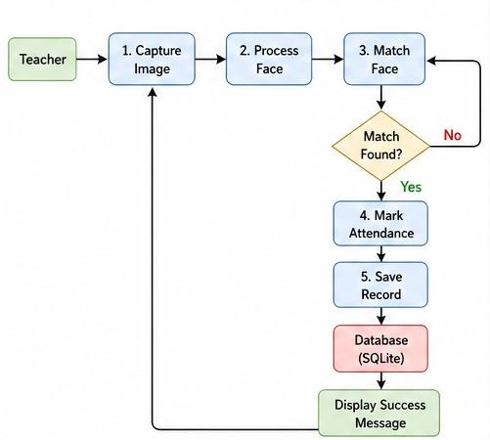

Sequence Diagram

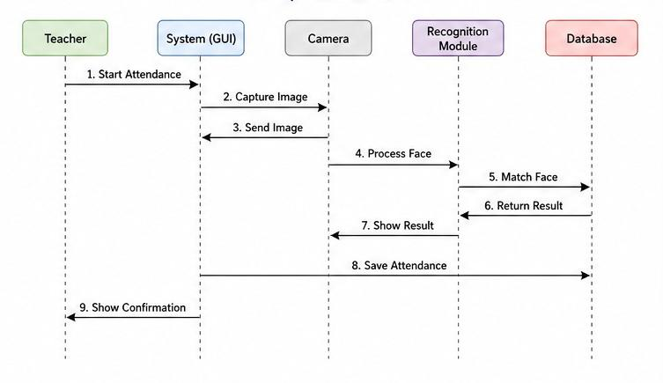

Flowchart

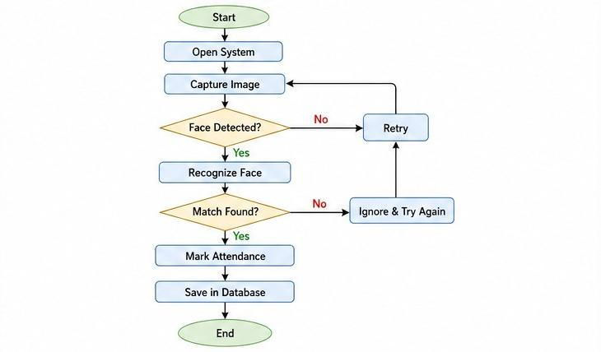

13. Future Enhancements
- Cloud-based storage
- Mobile application integration
- Real-time monitoring system
